**Algorithm**

**(Code)**

**3) Random Forest Tree:**

* import numpy as np

import pandas as pd

%matplotlib inline

import matplotlib.pyplot as plt

* data = pd.read_csv("housingnew.csv")

print(data)

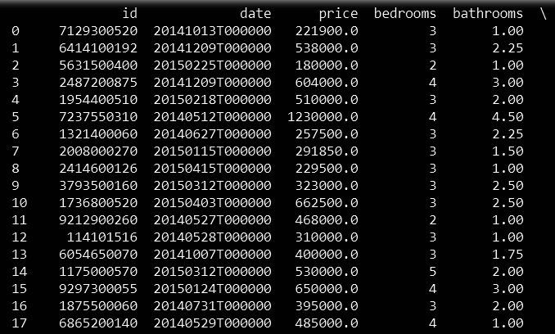

* data.describe()

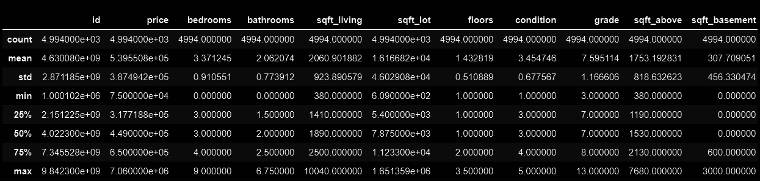

* X = data.drop(["id","date","price"], axis = 1)

y = data.price

print(X)

print(y)

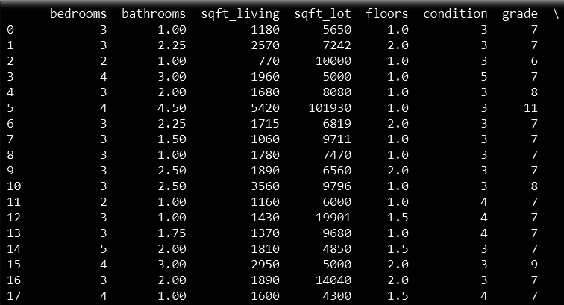

* from sklearn.model_selection import train_test_split

x_training_set, x_test_set, y_training_set, y_test_set = train_test_split(X,y,test_size=0.20, random_state=100,shuffle=True)

* from sklearn.ensemble import RandomForestRegressor

n_estimators=100

***# Fit regression model***

***# Estimate the score on the entire dataset, with no missing values***

model = RandomForestRegressor(random_state=0, n_estimators=n_estimators)

model.fit(x_training_set, y_training_set)

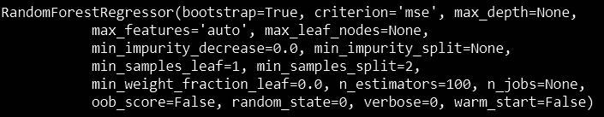

* model.score(x_test_set,y_test_set)



* from sklearn.metrics import mean_squared_error, r2_score

model_score = model.score(x_training_set,y_training_set)

***# Have a look at R sq to give an idea of the fit ,***

***# Explained variance score: 1 is perfect prediction***

y_predicted = model.predict(x_test_set)

***# The mean squared error***

print("Mean squared error: %.2f"% mean_squared_error(y_test_set, y_predicted))

***# Explained variance score: 1 is perfect prediction***

print('Test Variance score: %.2f' % r2_score(y_test_set, y_predicted))



* plt.scatter(model.predict(X), model.predict(X) - y,

color = "green", s = 10, label = 'Train data')

plt.hlines(y = 0, xmin = 0, xmax = 5000000, linewidth = 2)

plt.legend(loc = 'upper right')

plt.show()

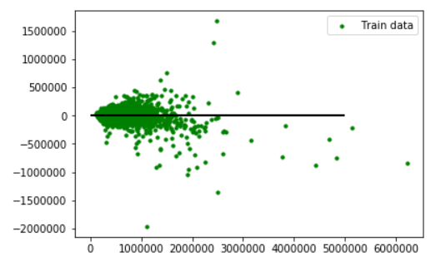

* plt.scatter(model.predict(x_test_set), model.predict(x_test_set) - y_test_set,

color = "blue", s = 10, label = 'Test data')

plt.hlines(y = 0, xmin = 0, xmax = 4000000, linewidth = 2)

plt.legend(loc = 'upper right')

plt.show()

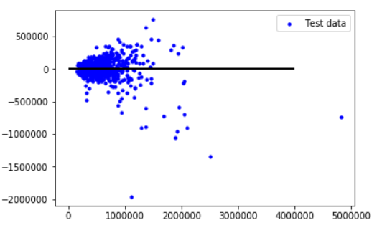

* plt.scatter(model.predict(X), model.predict(X) - y,

color = "green", s = 10, label = 'Train data')

***## plotting residual errors in test data***

plt.scatter(model.predict(x_test_set), model.predict(x_test_set) - y_test_set,

color = "blue", s = 10, label = 'Test data')

***## plotting line for zero residual error***

plt.hlines(y = 0, xmin = 0, xmax = 5000000, linewidth = 2)

plt.legend(loc = 'upper right')

***## plot title***

plt.title("Residual errors")

***## function to show plot***

plt.show()

